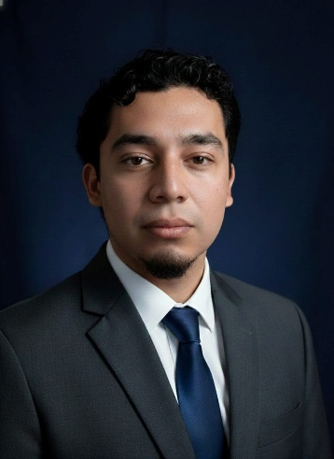 | Walter Edenilson Ramirez Deras  Software Developer

Santa Tecla, La Libertad, El Salvador • walterrd503@gmail.com • +503 7656 2084

Professional Profile

Software Developer with hands-on experience in the full web development lifecycle (Full Stack). Focused on building enterprise solutions and RESTful APIs using Laravel, Vue.js, and relational databases. Highly adaptable to new operational environments, prioritizing clean architecture, internal process automation, and functional code validation. Eager to continuously learn new tools and technologies such as Docker and NestJS.

Technical Competencies
Backend: PHP (Laravel), C#, Node.js (Concepts), Python (Basic).
Frontend: JavaScript, TypeScript, Vue.js (Vue Router, Pinia), Tailwind CSS, Bootstrap, HTML5, CSS3.
Databases: MySQL, SQL Server, PostgreSQL, Dexie.js (Local Storage), MongoDB (Basic).
Tools & Testing: Git, GitHub, Postman (API Testing), Docker, Axios, XAMPP, Visual Studio Code.
Systems: Basic Linux/Windows server administration (SSH, FTP).

Professional Experience
Monitoring and Systems Development Analyst | Lucas Monitoring Solutions July 2026 – Present
- Perform retrospective audits and real-time monitoring of transactions on delivery platforms (e.g., Uber Eats) to identify and document operational anomalies or sales discrepancies.
- Develop and implement internal tools and systems designed to automate repetitive tasks and optimize the monitoring team's workflow.
- Create detailed event logs and incident reports to ensure error traceability and facilitate prompt resolution.
Customer Service Representative | TELUS Digital February 2026 – June 2026
- Provided inbound customer support for inquiries related to banking products and services.
- Executed strict security protocols, regulatory compliance, and identity verification procedures to prevent account discrepancies.
- Resolved inquiries regarding accounts, transactions, and financial services, delivering effective and timely solutions.
- Maintained high standards of quality and customer satisfaction through clear and professional communication.
- Managed multiple systems and tools simultaneously to accurately document and track customer cases.
Full Stack Developer (Freelance) | ERP System for Recicladora Fernández September 2025 – January 2026
- Developed a comprehensive, custom ERP system using Laravel and Vue.js, achieving full digitization of the company's inventory and personnel management.
- Designed the MySQL database architecture, optimizing queries for real-time inventory reporting.
- Implemented authentication modules and user role management to ensure the integrity of sensitive business data.
- Executed pre-deployment functional testing to guarantee system availability and stability in a production environment.

Featured Projects

Enterprise WFM & Time Tracker (Personal Project)
- Workforce management platform developed with Laravel and MySQL.
- Implemented logic for shift auditing and database concurrency protection, ensuring highly accurate payroll reporting.
Nutri Time - Full Stack Web Platform (Personal Project)
- End-to-end development of an interactive platform, separating business logic into a robust RESTful API (Laravel, MySQL) and a dynamic user interface (Vue.js, Tailwind CSS).
- Implemented CRUD operations, a secure authentication system, and efficient data consumption via Axios without page reloads.
LifeOS Daily Planner (Personal Project)
- Daily planner application built with Vue 3, TypeScript, and Tailwind CSS.
- Local-first architecture utilizing Dexie.js and Pinia to ensure offline performance and complex state management.

Academic background

- Software Development Technician ITCA-FEPADE, Santa Tecla | Graduate
Intensive training in programming logic, relational databases, and network administration.
- Advanced English Certification Direct English | Graduate
Advanced level focused on conversational fluency and technical comprehension.
- Languages
Spanish: Native.
English: Advanced (Full professional proficiency, proven experience in bilingual customer service).

